**Project Title:**

Conversion of HTML Template into Laravel project.

**Submitted By:-**

**Name:** Nisha Jagtap

**Course:** Diploma in Computer Engineering

**Technologies Used:**

* Laravel 10+
* PHP 8.x
* Composer
* HTML5, CSS3, JS (from the original template)
* Blade Templating Engine

**Steps Taken:**

1. Downloaded the Retnews HTML template.
2. Installed Laravel using Composer.
3. Created a layout file (layouts/app.blade.php) and extracted the header/footer into partials/.
4. Converted each HTML page into Blade files using Laravel's Blade syntax.
5. Moved Blade pages into a pages/ folder for better structure.
6. Defined routes in web.php for all static pages.
7. Verified the layout works and all pages display correctly.

**Folder Structure Overview:**

resources/  
├── views/  
│ ├── layouts/  
│ │ └── app.blade.php  
│ ├── partials/  
│ │ ├── header.blade.php  
│ │ └── footer.blade.php  
│ └── pages/  
│ ├── about.blade.php  
│ ├── blog.blade.php  
│ ├── blog-single.blade.php  
│ ├── categories.blade.php  
│ ├── contact.blade.php  
│ ├── privacy.blade.php  
│ ├── terms.blade.php  
│ └── error.blade.php  
home.blade.php  
routes/  
└── web.php

**Screenshots:**

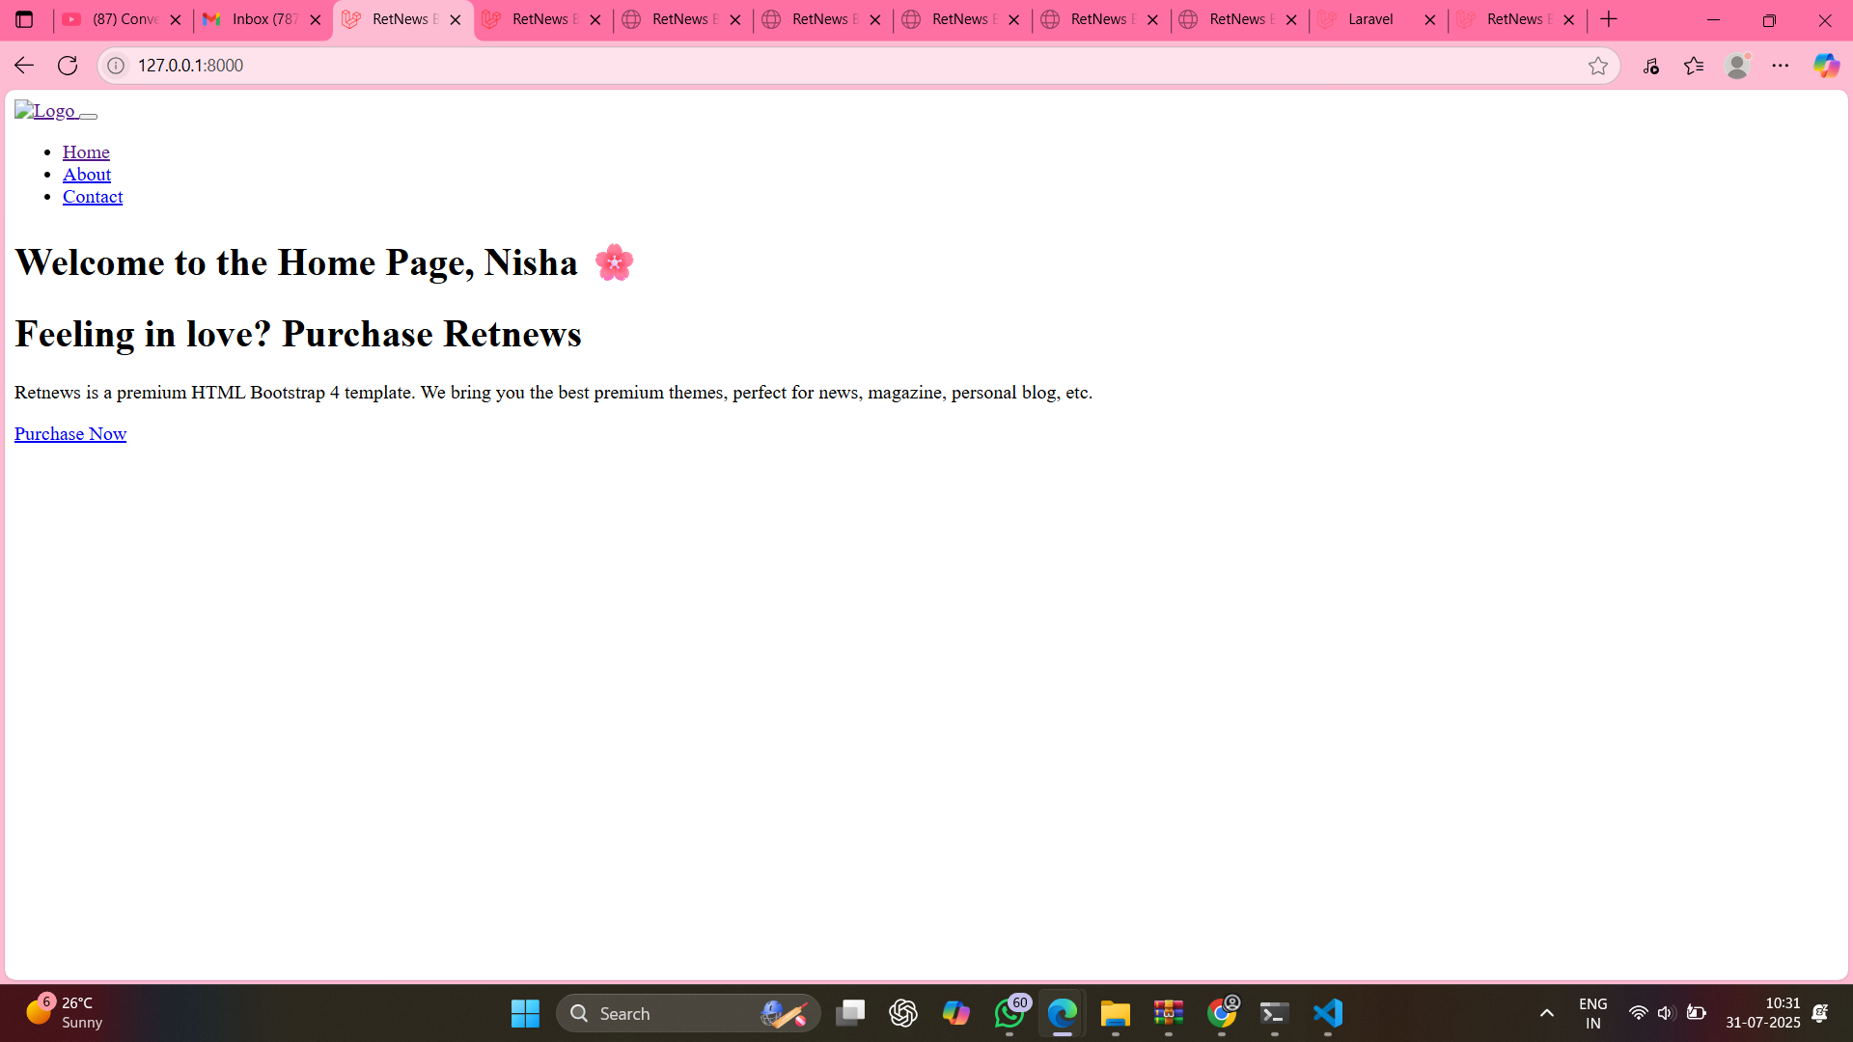

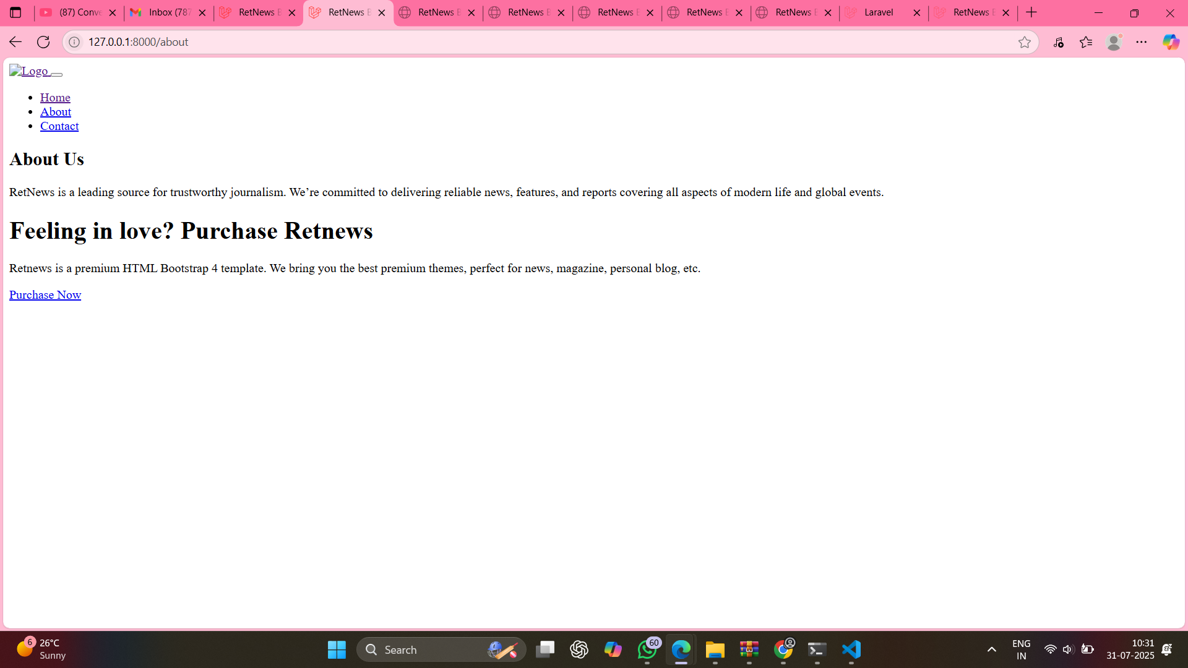

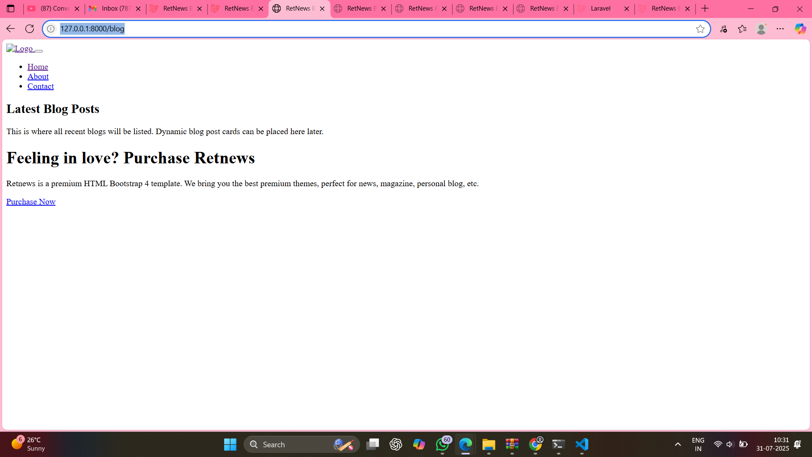

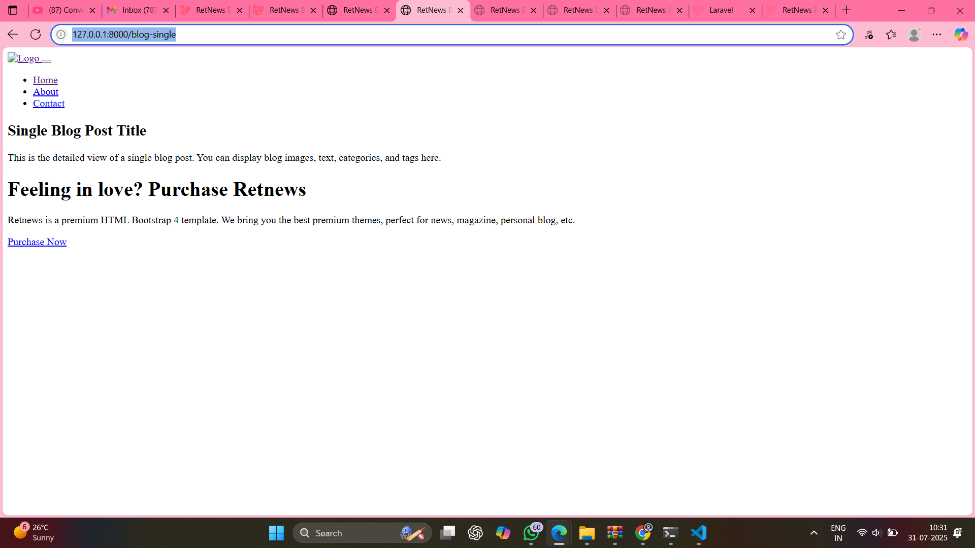

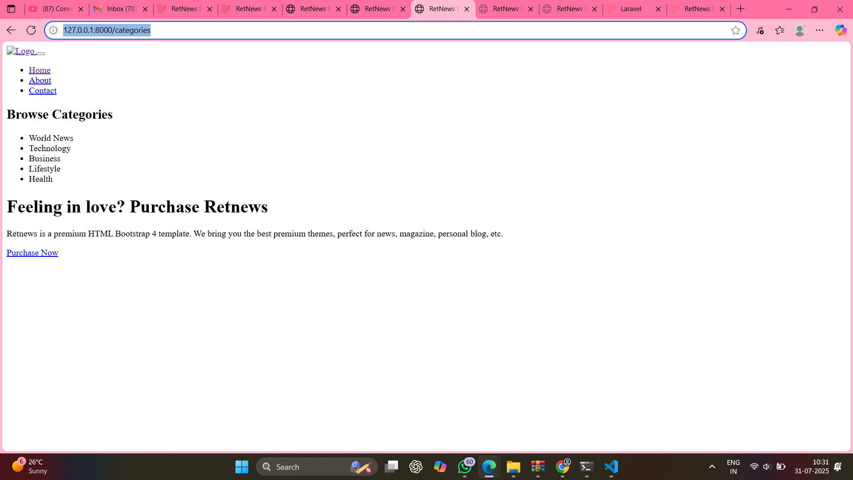

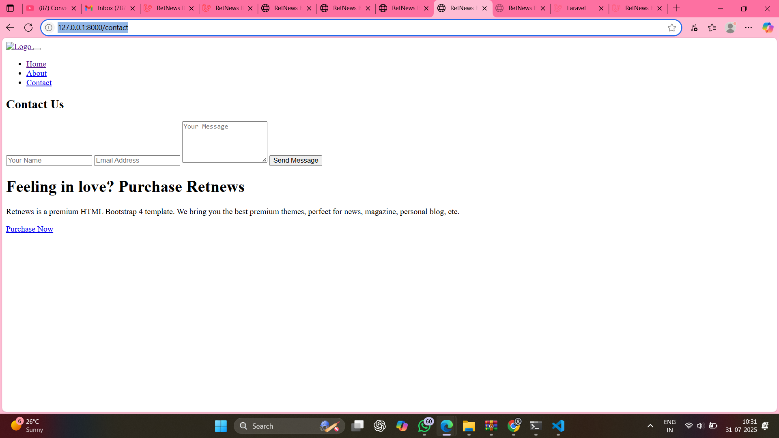

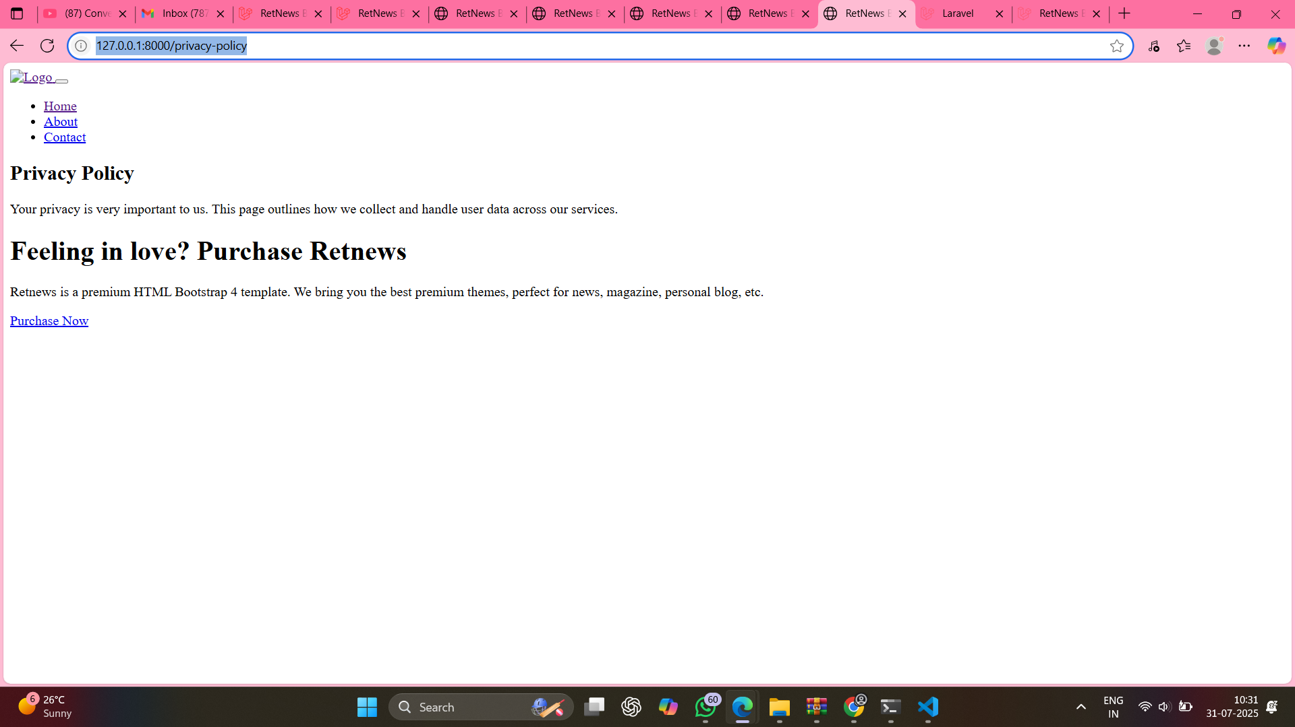

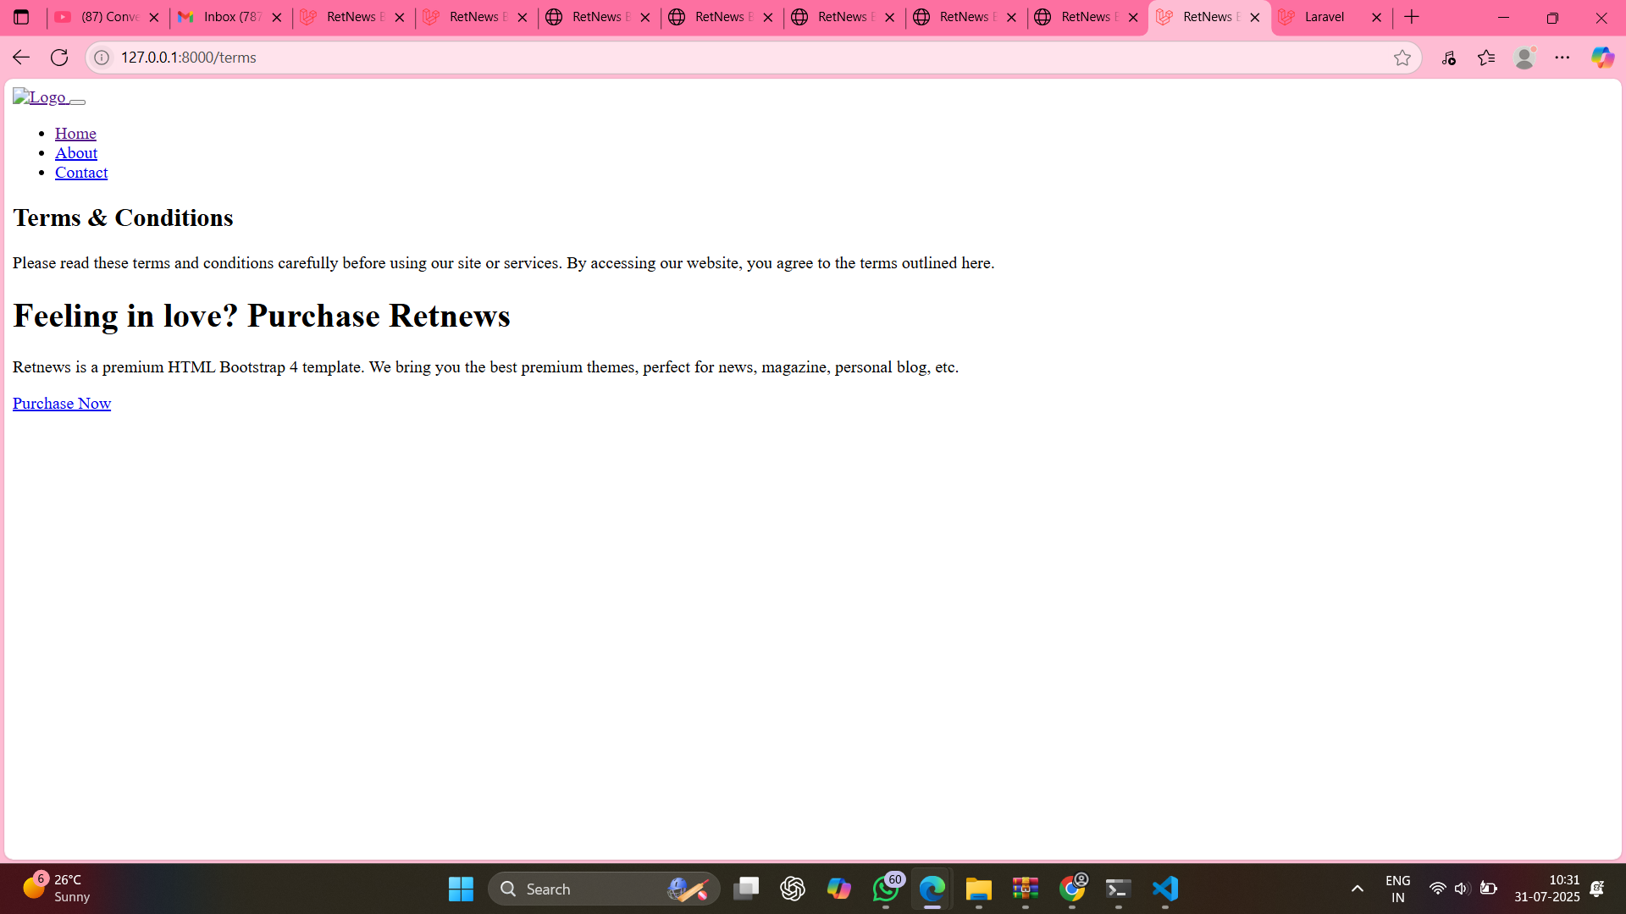

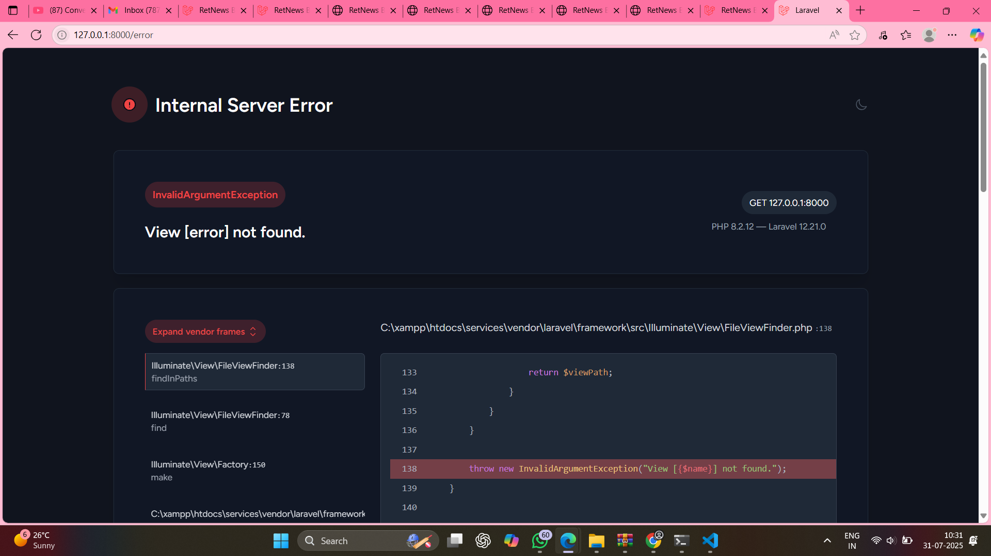

The given static HTML template was successfully converted into a Laravel-based web application. This project demonstrates an understanding of Laravel’s routing, views, layouts, and file structuring principles. The website is modular, maintainable, and follows Laravel best practices.